Co2 System
The Co2 Station is a significant departure from the industrial Co2 systems typically used for instrumental insemination and needs to be fully understood and managed. Failure to understand the Co2 system will be a source of problems for the user. If you as the user are used to using a large industrial cylinder you may have developed a habit to not be concerned about the amount of Co2 available to you. You will quickly become cognizant of Co2 conservation with this system. It is critical to follow the steps listed here to be successful.
- Cartridge Installation/Removal: Prior to installing or removing the cartridge shut off all three control valves. Use only 74g Co2 cartridge. It is recommended to use ONLY 74 gram cartridges that are intended for beverage dispensing systems. DO NOT USE Co2 CARTRIDGES INTENDED FOR PAINT BALL GUNS OR FISH TANKS. 74g Co2 cartridges intended for beverage service contain food grade Co2 and will do your queens no lasting harm. Aside from the quality of the Co2 contained in the cartridge, the threads and seals in the Queen Station^{tm} regulator may not match other cartridges. Spare cylinders can be obtained locally from brewery stores, on-line from brewery stores or directly from Apis Engineering.
Installing the Co2 cartridge is straight forward. Simply screw the cartridge into the threads on the regulator body. There is a small projection inside the Co2 regulator body that pierces the seal over the cartridge. It is important that the cartridge be screwed on completely and hand tight without stopping the threading motion. If the user interrupts the threading motion it is possible to cause the gas to escape before the cartridge is fully seated against the seal.

Once the cartridge is installed it should not be removed until it is empty. If there is Co2 gas remaining in the cartridge and it is removed the gas will escape and the cartridge will completely empty. It cannot be sealed and reused. The cylinder, if removed with Co2 gas remaining, will not present a danger except that ice may form on the exterior of the cartridge.

- Water Fill: With all three control valves closed the bubble counter can be filled with water. Note: only distilled water should be used in the bubble counter. Distilled and de-ionized water is acceptable but not required. The bubble counter is filled by removing the small thumb screw on the top of the polycarbonate tube. Included with your instrument is a 3 ml blunt tipped syringe. Fill this syringe with distilled water and then fill the bubble counter through the thumb screw hole. The red fill line on the bubble counter tube is approximately 3ml. Fill the polycarbonate tube to the red line. Replace the screw making sure the small O-ring is still on the screw. From time-to-time the bubble counter will need refilled. This is because minute amounts of the water bind to the Co2 and is carried out of the system. When the user needs to “top off” the system all valves need to be closed and the system recharged with Co2 as described below.

- Pressure Adjustment Procedure: In order to eliminate wasting Co2 and hence premature depletion of Co2 cartridge the following procedure must be adhered to.
  - Check to make sure all three control valves are closed. The valves will be off if the step #1 (above) was followed.
  - After installation of Co2 cartridge turn the regulator knob clockwise to an indicated pressure of 5 psi as shown on the dial. At no time is more than 5 psi required to anesthetize queens. After any of the three valves have been opened the user needs to wait 15 seconds before opening the next valve. This 15 second delay allows the pressure to stabilize within the system. Keep in mind your goal is to produce a 3 bubble per second (bps) flow rate. This is an extremely small volume of Co2 gas and it takes time to fill the lines. It should be noted that Co2 is heavier than air and this works to your advantage within the system because all air will be driven out of the lines. Be patient here.
  - After waiting 15 seconds the next valve to open is the flow regulator. This is the big black knob with the red lock ring. The red lock ring needs to be lifted up in order to adjust the knob. Raise the red ring and open the knob (turn counterclockwise) one full turn. Push the red lock ring back down. Wait 15 seconds again. Opening this valve allows the Co2 gas to flow thru the lines to the bubble counter. At this point the bubble counter is pressurized but no bubbles are observable because the flow control valve on top of the bubble counter is closed. Bubbles can only appear once this valve is opened.
  - This section is the most critical adjustment. Slowly open the valve on top of the bubble counter by turning counterclockwise. If this valve is opened too quickly the built up pressure in the lines will drive all of the water out of the bubble counter and into the lines feeding the queen holder. After a small opening of the valve WAIT to see if any bubbles appear. Once bubbles appear the valve on the top of the bubble counter can be adjusted for approximately 3 bps. At this point you may recall reading in other publications that 8-10 bps is appropriate and in others you may have read that continuous Co2 is required. Why the differences? It simply a matter of bubble size. The bubbles generated in this system flow through a precise orifice that controls bubble size and 3 bps is adequate.
  - If after opening the valve on the top of the bubble counter doesn’t produce any bubbles then close this valve completely and go back to the flow control valve and lift up the red ring and open this valve another ½ turn. Push the red lock ring down and repeat section (d).

- Draining Bubble Counter: Occasionally it may be necessary to drain the system.
  - Shipping or Long Term Storage of Instrument: If the user needs to ship the instrument via any method i.e. air transport or ground the bubble counter should be drained. Additionally, if the instrument is to be stored for long periods it should be drained. This is needed for two reasons. 1) If you ship your instrument it will likely be turned on its side or upside down and the water may leak out. And 2) Long term storage and shipment may expose the instrument to freezing conditions. (Apis Engineering is not responsible for any shipment via air freight. It is the user’s responsibility to ensure that the carrier allows Co2 cartridges to be air shipped.)
  - Draining the Bubble Counter: If the instrument needs drained it is highly likely that you also need to disassemble it too. In any event, to drain the system the instrument needs to be disassembled. Once disassembled remove the small thumbscrew in the side of the bubble counter and turn the instrument upside down and allow the water to drain out of the thumbscrew hole.

- Temporarily Shutting Off Co2 Flow
  - Between Queens: After completing the insemination of a queen if the user is going to immediately inseminate another queen nothing needs to be done to shut off the Co2 flow. If, however, there is going to be some length of time (more than 3 minutes) it is an advantage to shut down the Co2 flow. To temporarily stop Co2 flow simply close the flow control valve on top of the bubble counter. As you turn the valve try to remember how many turns it required to completely close the valve. This will make it easier to restore flow if you have an idea of where the valve was previously set. Note: When you need to open the valve to restore Co2 flow, open the valve slowly and in small increments with a pause between each adjustment. In summary, for short term Co2 flow stoppages all of the valves do not need to be closed only the valve on top of the bubble counter.

- Long Term Shutting Off Co2 Flow
Finished Using the Instrument: Upon completion of insemination of queens it will be necessary to shut off Co2 flow. This is accomplished by closing all three valves. Close the valve on the Co2 regulator first. This is accomplished by turning the knob Counterclockwise. Once this valve is closed the pressure gauge will drop to zero. Next, lift the red ring on the flow control valve and close the valve by turning the knob Clockwise. Finally, close the valve on top of the bubble counter by turning the knob Clockwise.

- Connection to Insemination Instruments
The Co2 station can be connected to all types of II devices by using the included hoses and adapters. Available at additional cost is an adapter for the C02 regulator that allows the user to connect to an industrial Co2 cylinder.

Photo showing red fill line
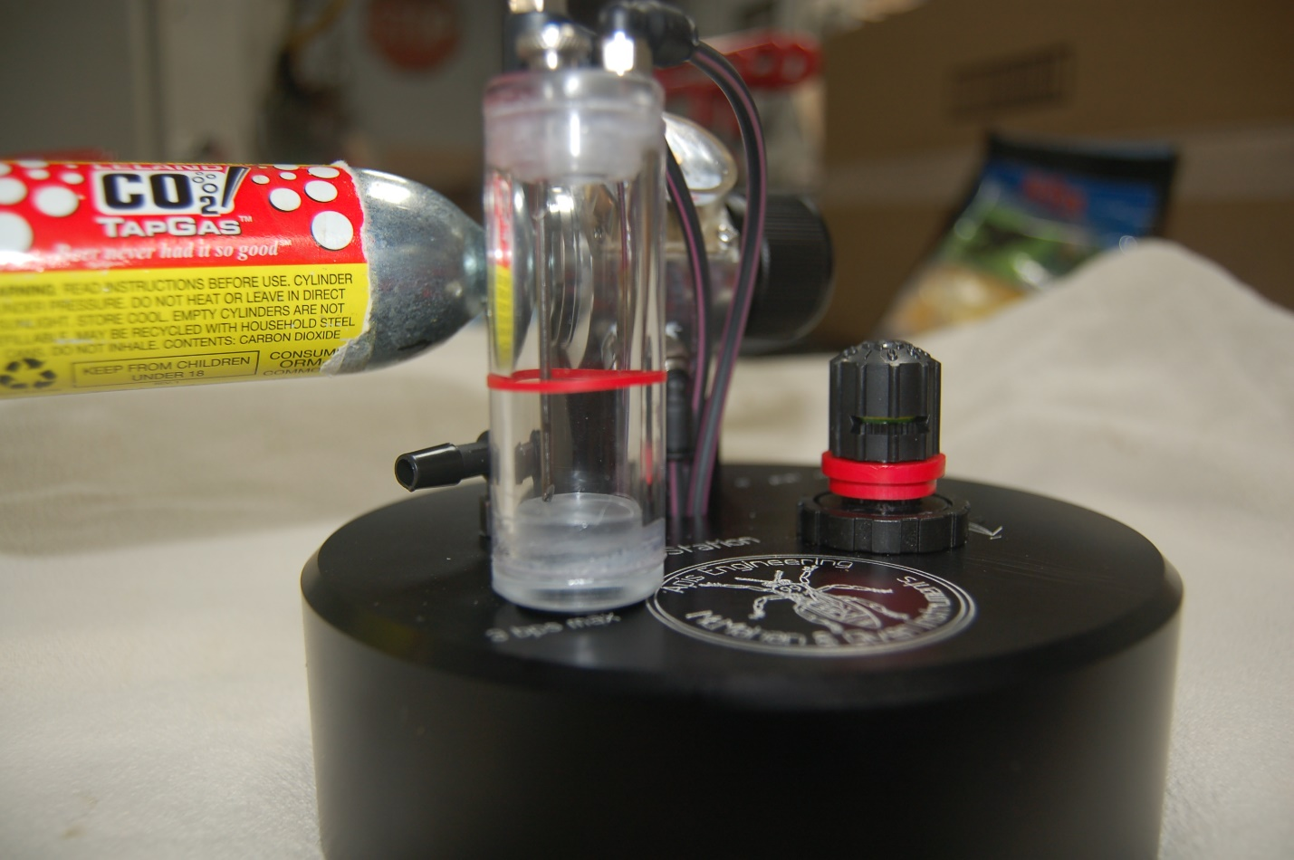

Photo showing 5 PSI mark on regulator
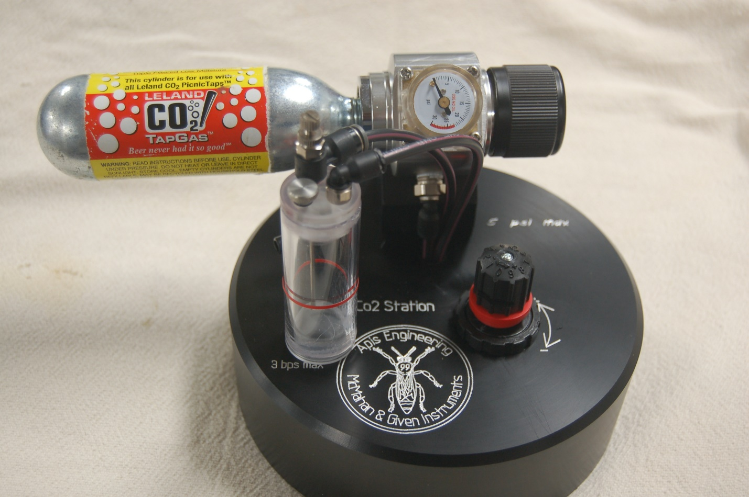

Secondary Anesthetization of Queens
Empirical evidence has shown that secondary anesthetization of queens causes them to begin laying sooner and for longer periods. Your instruments’ accessory kit box doubles as the secondary system. The box has vent holes in the lid and a Co2 port on its side. Also included is a connector hose that is to be attached to the queen holder post on the Queen Station^{tm} and the secondary box. The secondary anesthetization box will hold seven of the so-called California Mini cages. The flow rate for the secondary box is maintained at 3 bps. This rate will fill the box and force the air out through the holes in the lid. This will take several minutes. If you need to you can increase the bpm to something higher than 3 bpm but be aware an excessive rate may drive the water out of the bubble counter.

Photo showing secondary anesthetization
